WEB DEVELOPMENT

Mbedzi Masindi ST10491611
  - Proposal 2: Bright Minds Homework Helpers.

Table of Contents
Organisation Overview 2
Website Goals and Objectives 2
Current Website Analysis 3
Proposed Website Features and Functionality 4
Design and User Experience 4
Timeline and Milestones 5
Budget 6
REFERENCES 6

BRIGHT MINDS HOMEWORK HELPERS

Organisation Overview
Name: Bright Minds Homework Helpers
Brief History: Bright Minds Homework Helpers is a fictional non-profit initiative established in 2026 to support primary school children with their homework. The organization was designed to provide accessible, age- appropriate books and resources that simplify learning outside the classroom.
Mission and Vision: The mission is to empower children by giving them easy-to-understand homework support materials. The vision is to ensure that every child, regardless of background, has access to resources that make learning enjoyable (UNESCO, 2024).
Target Audience: Primary school children aged 6-12, parents and teachers who want structured learning materials.

Website Goals and Objectives
The website will act as a central hub for distributing educational books and resources. The objectives include:
. Promoting and distributing homework helper books.
. Providing downloadable worksheets and guides for parents.
Encouraging community engagement through reading clubs and forums.
KPIs: Success will be measured by the number of books downloads, parental engagement in forums and feedback from teachers (OECD,2023).

Current Website Analysis
As Bright Minds is fictional, there is no existing website. However, research into similar educational initiatives shows that many rely heavily on PDFs or printed materials, which limit accessibility. A dedicated website would provide structured book catalogues

Proposed Website Features and Functionality
Homepage: Featured books, latest resources and quick download links.
About Us: Mission, vision and team background.
Books & Resources: Categorized by grade level and subject.
Parent Zone: Guides on how to support children with homework.
Contact Page: Email, phone and social media links.
Community Forum: Space for parents and teachers to share tips.

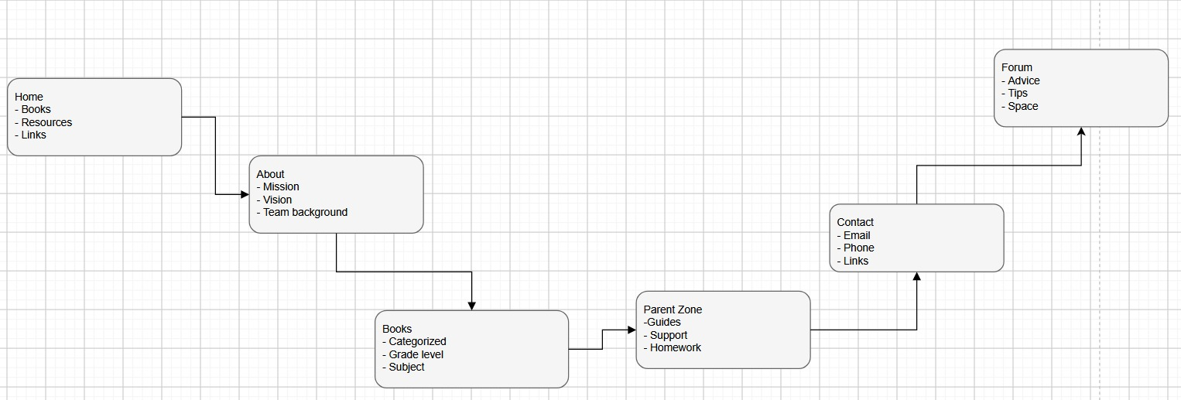

Design and User Experience
Color Scheme: Bright blue, yellow and white to reflect positivity and learning.
Typography: Friendly sans-serif fonts for readability by children and adults.
Layout: Simple, colorful and engaging with icons and illustrations.
User Experience: Easy navigation by grade level, mobile-friendly and interactive downloads.

Technical Requirements: The website will be hosted on a secure cloud hosting platform with SSL certification. The domain name will be brightmindbooks.org.za. Development will use HTML, CSS and JavaScript with WordPress CMS for flexibility.

Timeline and Milestones
. Week 1: Planning and content collection.
. Week 2-3: Development and integration of book catalogue and downloads.
. Week 4: Testing, feedback and launch.

Budget
. Development: R18,000
. Hosting: R2,000 per year
. Maintenance: R6,000 per year

REFERENCES
UNESCO (2024) Education for all: Primary learning resources. Available at: https://www.unesco.org (Accessed: 5 August 2026).
OECD (2023) Parental engagement in education. Available at: https://www.oecd.org (Accessed: 5 August 2026)

